INDIAN INSTITUTE of TECHNOLOGY ROORKEE



Department of Computer Science & Engineering

Project Report On
Using Data Mining to make Recommendation for Movies to watch to any viewer

Course- Data Mining (CSL-515)
Group 1 , Topic - 4

Group Members:
Sanskriti Chandra (24911021)
Tarushi Jain(25915024)
Atul Sharma(25911019)
Sumit Sharma(25911020)
Sara Mann (22114085)
Divij Rawal (22114031)

Under The Guidance of:
Dr. Durga Toshniwal
Professor, CSE, IIT Roorkee

Table of Contents:
S.No. | Section | Page No.
1 | Members’ Contribution ……………………………. | 2
2 | Introduction ………………………………………… | 3
3 | Problem Statement ………………………………… | 3
4 | The Dataset ……………………… | 4 - 6
5 | Dataset Preprocessing …………………………………... | 7 - 8
6 | Major Tasks ……………………………………  - Text Vectorization using TF-IDF…………..  - Content-Based Filtering……………………  - Actor Co-occurrence Graph………………..  - Exploratory Analysis and Rating Evaluation of IMDb Movies………………………..  Regional Diversity Feature Engineering using Alternate Titles  - Director Style Profiling………………... | 9 - 11  12 - 16  17 - 25  26 - 31  32 - 34  34 - 37
7 | Integration ………………………………………… | 38-40
8 | Results and Key …………… | 41
9 | Challenges, Future Work.. ……………………………. | 42
10 | Conclusion …………….. | 43

Members contribution:
S NO | Name | Enrollment No | Page No | Description of work
1 | Tarushi Jain | 25915024 | 9 - 11
2 | Sanskriti Chandra | 24911021 | 12 - 15 | Content-Based Filtering, Implicit Collaborative Filtering, and k-Means Clustering with Viewer Persona
3 | Atul Sharma | 25911019 | 17-25 | Graph-based actor community detection and cast similarity scoring for movie recommendations.
4 | Sumit Sharma | 25911020 | 25-31 | IMDb Movie Rating Analysis and Evaluation
5 | Sara | 22114085 |  | Regional diversity feature engineering using title.akas.tsv, exploratory analysis of regional/language coverage, localized-gem identification, and creation of diversity-signal features
6 | Divij Rawal | 22114031 |  | Created directorwise summary for movies using imdb data and use this information to suggest movies based on director similarity

1. Introduction
With thousands of movies available across streaming platforms and online databases, finding the right movie to watch has become increasingly difficult for viewers. People often spend more time searching for something to watch than actually watching it. This problem : known as information overload : is where recommendation systems come in. A good recommendation system helps a viewer discover movies they are likely to enjoy, without requiring them to manually search through thousands of options.
This project, developed as part of the course CSL-515 Data Mining and Warehousing at IIT Roorkee, presents a complete movie recommendation system built using data mining techniques as described in the textbook Data Mining: Concepts and Techniques by Han, Kamber, and Pei (3rd Edition). The system is built entirely on the publicly available IMDb non-commercial dataset, which provides rich structured information about movies, cast, crew, ratings, and regional distribution. No proprietary or paid data sources are used at any point in the project.
2. Problem Statement
Traditional recommendation systems, such as those used by Netflix or Amazon, rely heavily on user history : they track what a user has watched, rated, and searched for, and use that history to make personalised suggestions. This approach works well when a large amount of user data is available, but it fails in two common situations. First, when a viewer is new and has no history, the system has nothing to go on : this is known as the cold-start problem. Second, the IMDb public dataset, which this project uses, does not provide individual user ratings at all. It only provides aggregate information such as average rating and total vote count for each title.
This constraint makes standard collaborative filtering : one of the most commonly used recommendation techniques : impossible to apply directly. The challenge the project addresses is therefore: how do you build a high-quality, personalised recommendation system when you have rich movie metadata but no individual user behaviour data?

3. The Approach
Rather than simulating fake users or importing external datasets, this project takes a different route. It treats the aggregate rating data itself as an implicit signal of collective audience preference. Movies that are consistently rated highly within a particular genre, movies that attract a similar size of audience, and movies that come from directors with a similar stylistic fingerprint all of these patterns exist within the IMDb data and can be mined to derive meaningful recommendations without any individual user data.
The project is structured around six specialised modules, each developed by a different team member, each working on a different subset of the IMDb files. Every module applies a different data mining technique to its assigned data, and the outputs of all six modules are then merged in a final integration layer to produce one combined recommendation.
The six techniques used are content-based filtering using TF-IDF and cosine similarity, implicit collaborative filtering derived from genre-rating patterns and vote-tier affinity, actor co-occurrence graph mining using Louvain community detection, regional diversity feature engineering from alternate title data, director genre-style fingerprinting using cosine similarity on director profiles, and a multi-model ensemble combining KNN in SVD latent space with NLP title similarity. Together, these cover Chapters 2 through 12 of the Han, Kamber, and Pei textbook, making the project a comprehensive applied demonstration of the course material.

4. The Dataset
The project uses seven files from the IMDb non-commercial open dataset. (https://developer.imdb.com/non-commercial-datasets/) The title.basics.tsv file provides core movie information including genre, release year, and runtime. The title.ratings.tsv file provides the aggregate IMDb rating and vote count for each title. The title.principals.tsv file lists the principal cast and crew for each movie, including actors, actresses, and directors. The title.crew.tsv file lists the director and writer for each title. The title.akas.tsv file provides alternate titles across different regions and languages, which is used to measure a movie's international reach. The name.basics.tsv file provides names and biographical information for people in the entertainment industry. The title.episode.tsv file provides episode-level information for TV series.

basics | (12339113, 7)
principals | (49129794, 4)
crew | (12339113, 2)
akas | (55246785, 4)
movies_base | (143402, 13)
ratings | (1644346, 3)
All files are loaded once at the start of the system and shared across all six modules, making the design memory-efficient and avoiding redundant file reads that would exceed Kaggle's memory limits

File 1 title.basics.tsv
- Forms the foundation of the dataset with core movie information
- Contains all types of titles (movies, TV series, etc.)
- Only titleType = movie is used in this project
Key attributes:
- tconst: Unique movie ID (primary key used for joining datasets)
- titleType: Type of content (filtered to movies only)
- primaryTitle: Commonly used movie name (used in recommendations)
- originalTitle: Original language title
- startYear: Release year (used to compute decade feature)
- runtimeMinutes: Movie duration (missing values handled using median)
- genres: Comma-separated genres
  - Most important feature
  - Used in TF-IDF, encoding, clustering, and association mining

File 2 title.ratings.tsv
- Contains crowd-sourced rating information
- Smaller in size but critical for recommendation quality
Key attributes:
- tconst: Foreign key linking to basics file
- averageRating: IMDb weighted rating (1–10 scale)
- numVotes: Number of user votes
  - Helps measure reliability of rating

File 3 title.akas.tsv
Key attributes:
- titleId: Movie ID (renamed to tconst for merging)
- title: Alternate title
- region: Country code (e.g., US, IN)
- language: Language of title
- types: Type of alternate title (e.g., display, working)
- attributes: Extra descriptors (e.g., festival version)
- isOriginalTitle: Indicates original title (0/1)

File 4 title.crew.tsv
- Contains director and writer information
Key attributes:
- tconst: Movie identifier
- directors: Comma-separated director IDs
- writers: Comma-separated writer IDs

File 5 title.principals.tsv
- Contains main cast and crew details
- One of the largest files (multiple entries per movie)
Key attributes:
- tconst: Movie identifier
- ordering: Credit order (lower = more important role)
- nconst: Person identifier
- category: Role (actor, director, etc.)
- characters: Character names (for actors/actresses)

File 6 name.basics.tsv
- Contains information about people (actors, directors, etc.)
Key attributes:
- nconst: Unique person ID
- primaryName: Person’s name
- birthYear / deathYear: Life details
- primaryProfession: Professions (actor, director, etc.)
- knownForTitles: Notable works

File 7 title.episode.tsv
- Contains information about TV series episodes
- Links each episode to its parent TV series
- Not directly used in this project (since focus is on movies), but useful for extended analysis
Key attributes:
- tconst: Unique identifier for each episode
- parentTconst: Identifier of the parent TV series
- seasonNumber: Season number of the episode
- episodeNumber: Episode number within the season
All six files are linked through two types of identifiers. The tconst identifier connects title.basics, title.ratings, title.akas, title.crew, and title.principals any of these files can be joined to any other using tconst as the common key. The nconst identifier connects title.principals and title.crew to name.basics, allowing person-level information to be looked up from any title-level file that lists a person's nconst. In the combined notebook, all six files are loaded once at the start with only the columns each module actually needs, using the usecols parameter. They are then shared across all six modules as common dataframes, so no file is ever read from disk more than once. This design keeps memory usage within Kaggle's limits while giving every module full access to the data it requires.
5. Data Preprocessing

1. Data Loading and Initial Handling
- All IMDb .tsv files were loaded using pandas.
- Missing values represented as \N were converted to NaN.
- Large files (e.g., title.principals.tsv) were handled efficiently using selective column loading and filtering.

2. Filtering Relevant Records
- Only movies (titleType = 'movie') were retained for the recommendation system.
- TV series, episodes, and other non-movie content were excluded.
- For quality assurance:
  - Movies with very low votes were removed (thresholds varied by module, e.g., ≥100, ≥500).

3. Data Cleaning
- Converted relevant columns to appropriate data types:
  - startYear, runtimeMinutes, averageRating, numVotes → numeric
- Removed rows with missing or invalid values in key attributes:
  - genres, ratings, year, votes
- Standardized inconsistent entries (e.g., empty strings, malformed values)

4. Dataset Integration
- Multiple files were merged using primary and foreign keys:
  - tconst → links movie-related datasets
  - nconst → links people-related datasets
- Key joins performed:
  - title.basics + title.ratings
  - title.basics + title.principals + title.crew
  - title.principals + name.basics
- Additional mapping:
  - title.akas used for regional and alternate title analysis

5. Feature Engineering
To enhance model performance, several features were constructed:

a. Rating-Based Features
- Weighted Rating (Bayesian average):
  - Balances rating and vote count to reduce bias
- Log-transformed votes:
  - Handles skewness in popularity distribution

b. Temporal Features
- Decade extraction from release year
- Helps capture time-based viewing patterns

c. Genre Processing
- Genres split into lists and encoded using:
  - Multi-label binarization (for ML models)
- Used in:
  - Content-based filtering
  - Clustering
  - Association rule mining

d. Cast and Crew Features
- Extracted from title.principals and title.crew
- Selected key roles:
  - actor, actress, director, writer
- Top cast members selected based on ordering
- Aggregated into compact representations

e. Textual Features
- Created combined text (“soup”) including:
  - Genres
  - Cast
  - Temporal features
- Used for TF-IDF vectorization

6. Handling Sparsity and Noise
- Applied thresholds on numVotes to ensure reliable data
- Removed rare or insignificant entries
- Normalized features for similarity computations

7. Graph and Relationship Construction
- Built relationships between:
  - Movies and actors
  - Movies and directors
- Used in:
  - Actor graph mining
  - Director style modeling

8. Clustering Preparation
- Features scaled using standardization
- Combined:
  - Genre vectors
  - Rating and popularity features
- Prepared data for k-Means clustering

9. Final Dataset Preparation
- Created multiple processed datasets tailored for modules:
  - Content-based dataset
  - Collaborative filtering feature matrix
  - Clustering dataset
  - Graph-based structures
- A shared enriched movie table was created for integration across modules

6. Major Tasks

6.1 Text Vectorization using TF-IDF, K-Means Clustering, K-Nearest Neighbors(KNN) and Association Rule Mining
Files used: title.basics.tsv, title.episode.tsv

Objective:
The objective of this project is to develop a scalable and efficient movie recommendation system using large-scale IMDb datasets. The system focuses on analyzing movie metadata such as genres, release year, runtime, and textual information to recommend similar movies. By combining content-based filtering with clustering and pattern mining techniques, the model aims to capture both explicit similarities and hidden relationships between movies. The approach emphasizes handling large datasets, improving recommendation accuracy, and generating meaningful suggestions based on user input.

Dataset Files and attribute Used:
The key dataset files used are:
- title.basics.tsv: (12339113, 7)
  - Attributes: tconst, titleType, primaryTitle, startYear, runtimeMinutes, genres, isAdult.
  - Used as the primary dataset for extracting movie metadata and filtering only movie records
- title.episode.tsv: (9523422, 4)
  - Attributes: tconst, parentTconst, seasonNumber, episodeNumber
  - Used to identify and separate TV episodes from movies, ensuring that only standalone movies are included in the recommendation system
  - Helps in maintaining dataset consistency by avoiding mixing episodic content with movies

EDA and Preprocessing
The dataset initially contained missing values, inconsistent formats, and irrelevant records, which required thorough preprocessing before applying machine learning techniques. First, only relevant entries were retained by filtering records where titleType = movie and removing adult content using isAdult = 0, ensuring the dataset focuses strictly on standard movie recommendations. Missing values in important numerical attributes such as startYear and runtimeMinutes were handled using median imputation, i.e., replacing missing values with x~=median(X), which preserves distribution robustness. Textual preprocessing was performed by converting movie titles to lowercase and removing special characters, ensuring uniformity for text-based modeling. Additionally, duplicate entries based on tconst were removed to maintain data integrity.
Feature engineering played a crucial role in enhancing model performance. A new decade feature was derived using decade=⌊startYear/10⌋×10, allowing temporal grouping of movies. Genre information was transformed into structured formats including genre_list and genre_count, where genre_count=∣Gi​∣ represents the number of genres associated with a movie. A combined textual feature was constructed by concatenating genres, decade, and cleaned title, forming a rich representation for vectorization. Numerical features such as startYear, runtimeMinutes, and genre_count were normalized using MinMax scaling, defined as
X′ =( x − x_min) / (⁡x_max⁡ − x_min)⁡
to bring all values into a comparable range [0,1]. Furthermore, a popularity score was computed as a weighted combination:
Pop_score = 0.40⋅year_sc + 0.35⋅runtime_sc + 0.25⋅genre_sc
which captures the overall importance of a movie based on recency, duration, and genre diversity. These preprocessing steps transformed raw IMDb data into a structured, normalized, and feature-rich dataset suitable for advanced recommendation modeling.
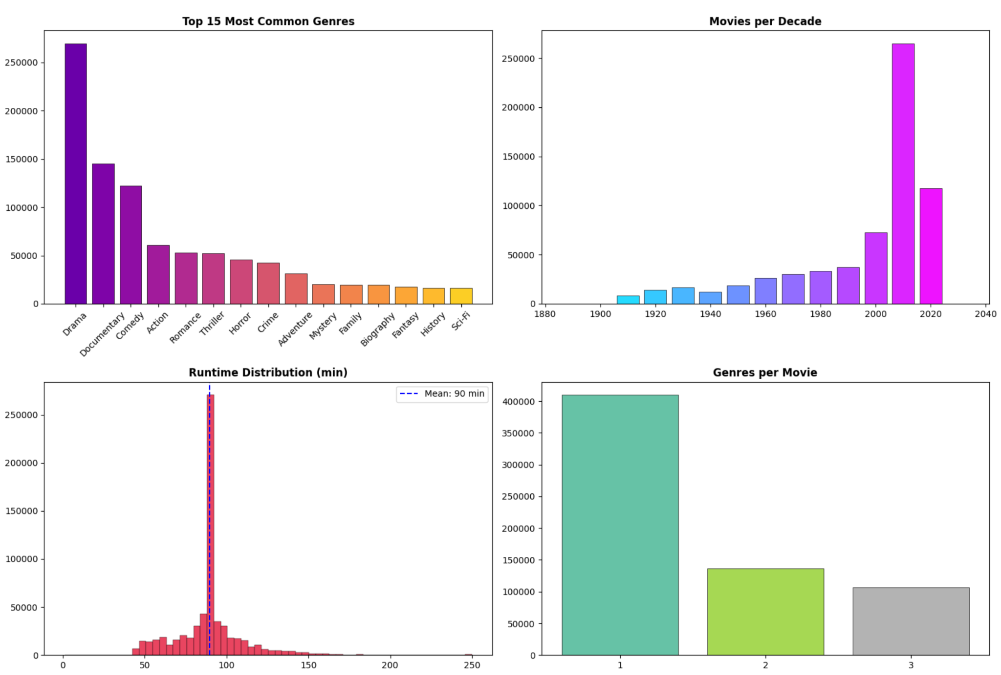
Algorithm Used:
The recommendation system adopts a hybrid approach by integrating multiple machine learning and data mining techniques to improve both accuracy and diversity of recommendations. Initially,
1. Content-Based Filtering (Term Frequency–Inverse Document Frequency + Cosine Similarity) is applied to convert textual features into numerical vectors. It is mathematically defined as:
TF-IDF(t,d) = TF(t,d) × log⁡(N/DF(t))
where TF(t,d) is the term frequency and DF(t) is document frequency. The features column fed into the vectorizer is a composite text field constructed from the movie's genre tags, primary title tokens, and other descriptive metadata (such as runtime category or year band, depending on your feature-engineering step). English stop words are removed to reduce noise. The resulting TF-IDF matrix has a shape of (652,680 × 45), means 652,680 movies are represented across a 45-dimensional vocabulary space — each dimension corresponding to one meaningful term surviving after stop-word filtering. Pairwise cosine similarity is then computed between the query movie's TF-IDF vector and every other row in the matrix; the top-N closest movies (by angle, not magnitude) are returned as recommendations. Cosine similarity is preferred here because it is scale-invariant, making it robust to differences in text length across movie entries.
This helps in capturing the importance of genres and keywords across movies. To reduce the high dimensionality of TF-IDF vectors, Truncated SVD is applied, decomposing the matrix as A≈UΣVTA, thereby extracting latent semantic features and improving computational efficiency.
2. K-Means Clustering Before clustering, TruncatedSVD (Latent Semantic Analysis) reduces the 45-dimensional TF-IDF matrix to 44 latent components, with the resulting shape of (652,680 × 44), retaining the dominant semantic structure while discarding sparse, noisy dimensions and dramatically cutting the computational cost of clustering on 652K rows.
K-Means is then applied to the 44-dimensional reduced space with K = 12. The value was selected using the Elbow Method — plotting inertia (within-cluster sum of squared distances) against increasing values of K. The curve shows a pronounced "elbow" at K = 12, meaning adding more clusters beyond this point yields diminishing returns in inertia reduction. With 652,680 movies spanning genres like Action, Drama, Comedy, Horror, Documentary, Animation, Thriller, Romance, Sci-Fi, Crime, Family, and Biography, 12 clusters maps intuitively to the major thematic/genre groupings in the catalogue. Each cluster captures a semantically coherent neighbourhood in the TF-IDF latent space, so movies assigned to the same cluster as the query film share meaningful content DNA, not just surface-level genre labels.
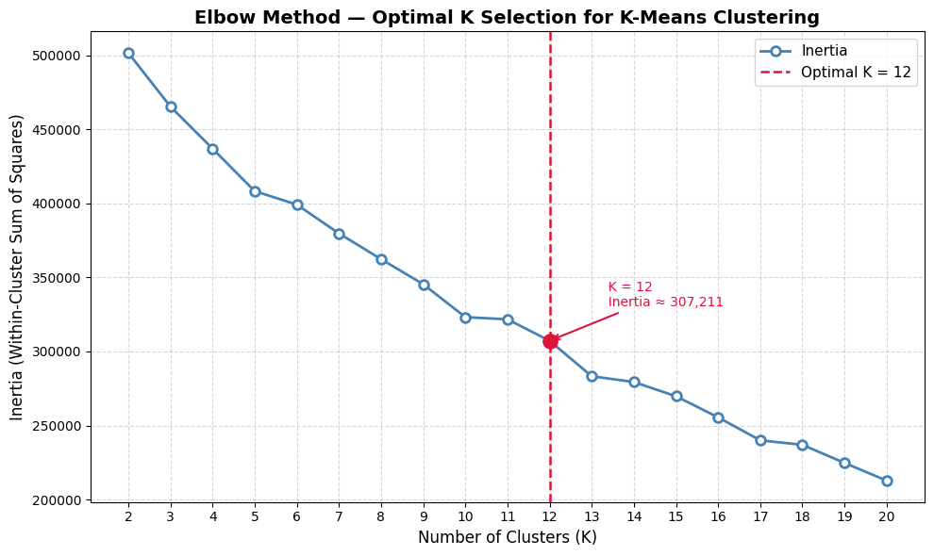
3. Popularity-Based Filtering recommends movies that are objectively well-received across the entire user base, requiring no user history or personalisation. This makes it the ideal cold-start solution — used when the system knows nothing about the user yet. It is useful for sections like "Trending" or "Top Action Movies."
4. Apriori Algorithm (Association Rule Mining) treats each movie's genre list as a transaction (e.g., {Action, Thriller, Crime}) and mines frequent genre co-occurrence patterns across the full catalogue.
Hyperparameters chosen:
Parameter | Value
Min_Support | 0.02 | A genre combination appearing in at least 2% of 652,680 movies (~13,054 movies) is considered frequent. Setting it lower would generate an exponential number of itemsets and rules from rare, noisy combinations; setting it higher would miss meaningful but moderately common pairings like {Animation, Family}.
Min_Confidence | 0.30 | Given that the antecedent genre(s) are present, the consequent genre must appear in at least 30% of those cases. This threshold filters out weak, coincidental associations while still retaining rules that reflect genuine co-viewing patterns (e.g., if a movie is Drama, there's a meaningful probability it's also Romance).

5. Hybrid Model (Content + Popularity) The hybrid recommender blends the strengths of content-based filtering and popularity-based ranking through a weighted linear combination:
Hybrid Score=0.7×Content Similarity (normalised)+0.3×Popularity (normalised)
Both the cosine similarity scores and the weighted popularity scores are min-max normalised to [0, 1] before combining, ensuring neither signal dominates due to scale differences.
Weight choice rationale:
- The 70% content weight prioritises relevance - the recommended movie should genuinely resemble the query movie in genre, theme, and narrative character.
- The 30% popularity weight acts as a quality tiebreaker - when two movies are equally similar to the query, the more widely seen and better-rated one is surfaced first, improving the practical usefulness of the output.

6.2 Content-Based Filtering, Implicit Collaborative Filtering, and k-Means Clustering with Viewer Persona
Files Used: title.basics.tsv, title.ratings.tsv, title.principals.tsv

Objective
The objective of this task is to build the recommendation engine. Since the IMDb dataset provides no individual user ratings, this task develops two complementary approaches : content-based filtering using TF-IDF similarity and implicit collaborative filtering derived from genre-rating patterns : and combines them into a hybrid model. Additionally, k-Means clustering is used to group movies into taste segments, which enables a Viewer Persona system that solves the cold-start problem for new users without requiring any viewing history.
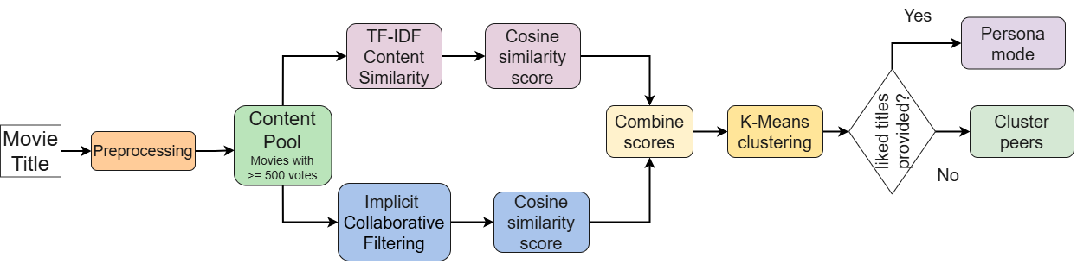
Fig. Workflow of the task.

6.2.1. Files and Attributes Used
From title.basics.tsv, the attributes tconst, titleType, primaryTitle, originalTitle, isAdult, startYear, endYear, runtimeMinutes, and genres are loaded. From title.principals.tsv, the attributes tconst, ordering, nconst, category, job, and characters are used. From title.ratings.tsv, the attributes tconst, averageRating, and numVotes are used. The tconst identifier serves as the common key across all three files, allowing them to be merged into a single unified movie table.

6.2.2. Exploratory Data Analysis and Preprocessing
Before any modelling begins, the data is explored and cleaned. Missing value analysis is performed on all three files. In title.basics.tsv, the endYear column has the highest proportion of missing values at 98.8%, followed by runtimeMinutes at 64.1% and startYear at 11.8%. The genres column has 4.3% missing values. In title.principals.tsv, the job column is missing for 81.0% of rows and the characters column for 51.2%, which is expected since these fields are only applicable to specific crew categories.
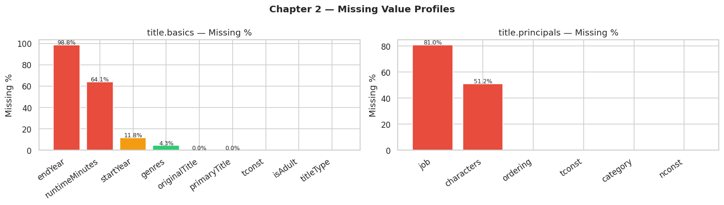
Fig. Missing attribute percentages from files title.basics and title.principals.
The distribution of ratings shows that the mean averageRating across all titles is approximately 6.97 with a median of 7.2, indicating that the distribution is slightly left-skewed. The distribution of log(numVotes) has a mean of 3.82 and a median of 3.33, confirming that the majority of titles have relatively few votes and a small number of highly popular titles attract a disproportionately large share of votes.
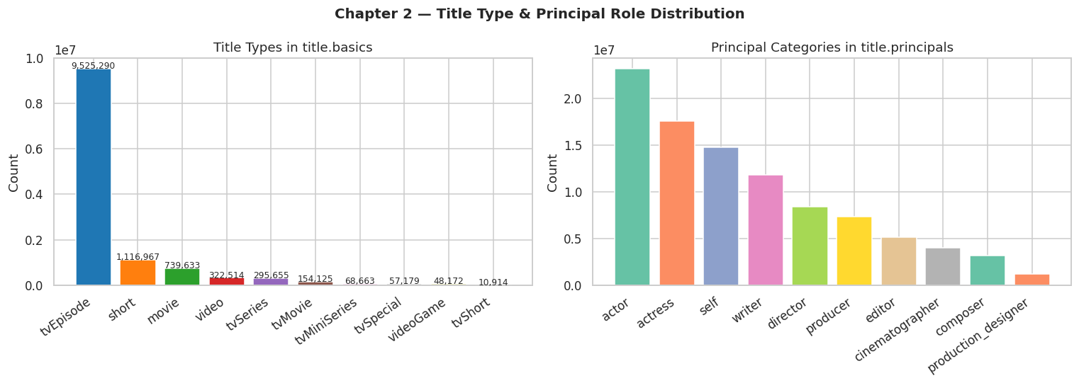
Fig. Title type and principal Role distribution.
After exploration, the data is preprocessed as follows. The basics file is filtered to retain only rows where titleType equals movie. The filtered movies are merged with the ratings file using tconst as the join key. Rows with missing values in the genres, startYear, averageRating, or numVotes columns are dropped. A minimum vote threshold of 100 is applied to remove unreliable titles. The Bayesian Weighted Rating is then computed for each movie using the formula:
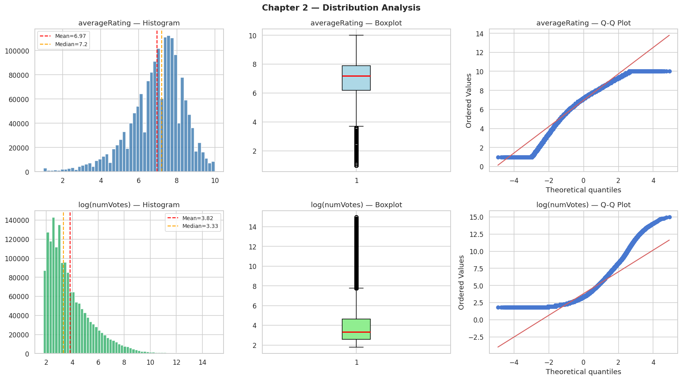
Fig. Histogram analysis of titles.ratings attributes with num_votes right skewed and average_rating left skewed..
WR = (v / v + m) × R + (m / v + m) × C
where v is the number of votes for the movie, m is the 60th percentile of all vote counts, R is the average rating, and C is the global mean rating. This formula ensures that movies with very few votes do not rank artificially high. Additional features are engineered including log_votes as the log-transformed vote count, decade derived from the release year as decade = (startYear // 10) * 10, that is around 13 distinct decade tokens.
, and genre_list as the genres split into a Python list. From the principals file, the top three cast members per movie by ordering are aggregated into a cast_ids string. The resulting content pool, filtered to movies with at least 500 votes, forms the input to all downstream models.

6.2.3. Content-Based Filtering
Content-based filtering is used to find movies that are similar in genre, cast, and era to a query movie. For each movie in the content pool, a text representation called a soup string is constructed by concatenating the genre tokens repeated three times (to give them higher TF-IDF weight), the cast IDs, and a decade token of the form decade_2000 or decade_2010. Repeating the genre tokens three times ensures that genre similarity carries more weight than cast or era similarity in the final TF-IDF representation.
Step | Detail
Input | genres (×3), cast IDs, decade token joined into one text string per movie
Model | TF-IDF Vectoriser with max 5,000 features
Similarity | Cosine similarity between the query movie vector and all other movie vectors
Output | Top-N most similar movies with a content_score
The TF-IDF vectoriser converts each movie's soup string into a numerical vector of term frequency-inverse document frequency weights.
TF and IDF are actually calculated as: the soup for The Dark Knight looks like this:
“Action Crime Drama Action Crime Drama Action Crime Drama nm0000288 nm0001631 decade_2000”
TF (Term Frequency) for this one movie's soup:
Action appears 3 times out of 12 total tokens → TF = 3/12 = 0.25
nm0000288 appears 1 time out of 12 → TF = 1/12 = 0.083
IDF (Inverse Document Frequency) across all movies in the pool:
Action appears in say 80,000 out of 100,000 movies → IDF = log(100,000/80,000) = 0.22 (low - very common)
nm0000288 appears in say 40 out of 100,000 movies → IDF = log(100,000/40) = 7.8 (high -very rare)
TF-IDF score = TF × IDF:
Action → 0.25 × 0.22 = 0.055 (low weight)
nm0000288 → 0.083 × 7.8 = 0.65 (high weight)
Cosine similarity is then computed between the query movie's vector and all other movies' vectors. The resulting similarity scores, normalised between 0 and 1, are ranked in descending order and the top-N results above the minimum vote threshold are returned as content-based recommendations.

6.2.4. Implicit Collaborative Filtering
Standard collaborative filtering requires individual user ratings, which are not available in the IMDb public dataset. To address this, an implicit collaborative filtering approach is developed that derives similarity signals entirely from the aggregate rating data.
Since no user ratings are available, two implicit signals are used as substitutes.
1) The first signal is the genre-rating profile. For each genre, the crowd-average weighted rating is computed as a benchmark of what a typical movie in that genre scores. Each movie is then assigned a deviation vector representing how its rating compares to each genre's average across every genre dimension it belongs to. Movies that deviate in similar ways from the genre benchmarks are assumed to appeal to the same type of viewer.
2) The second signal is vote-tier affinity. Movies are discretised into five popularity tiers Obscure, Niche, Known, Popular, and Blockbuster based on their vote count. Movies in the same tier share a similar audience size and engagement level, which acts as an implicit indicator of shared viewership patterns. Both signals are normalised row-wise using L2 normalisation and combined into a single implicit CF matrix with a 60/40 weighting in favour of the genre-rating profile. Cosine similarity on this combined matrix gives the CF score for each candidate movie. The distribution of user-user similarity scores computed from this implicit matrix has a mean of approximately 0.026, confirming that the signals are discriminative; most pairs of movies are dissimilar, while a small number share strong audience-pattern alignment.
The final hybrid recommendation score is computed as:
mod2_score = 0.60 × content_score + 0.40 × cf_score
This combination leverages the precision of content-based filtering for genre and cast matching with the audience-pattern awareness of the implicit CF signal.

6.2.5. k-Means Clustering and Viewer Persona System
k-Means clustering is applied to group movies into natural taste segments based on their genre profile and rating characteristics. The feature matrix for clustering is constructed from the genre binary columns with a weight of 2, combined with StandardScaler-normalised averageRating and log_votes values. The optimal number of clusters k is selected automatically by testing silhouette scores for values of k from 3 to 11. Based on the silhouette score curve shown below, the best k is identified as 11. The elbow curve of inertia versus k shows a consistent decline, while the silhouette score peaks at k = 11, confirming that 11 clusters provide the most meaningful grouping of movies by genre and quality characteristics. Each movie in the content pool is assigned a cluster label after fitting the final k-Means model.
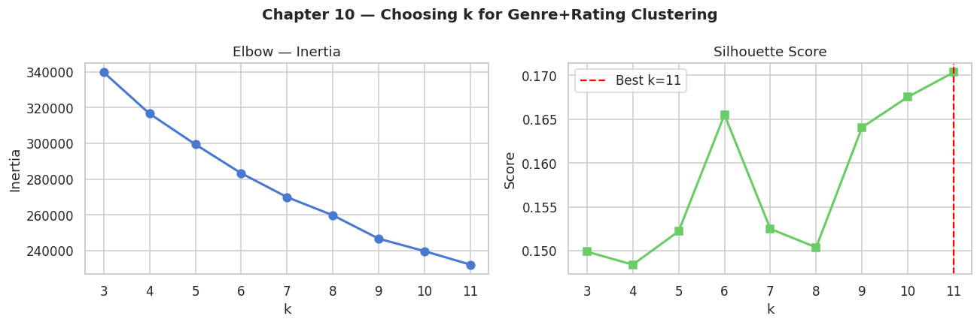

Fig. Choosing k for Genre + rating clustering.
Step | Detail
Features | Genre binary columns (×2 weight) + scaled averageRating + log_votes
k selection | Silhouette score tested for k = 3 to 11, best k chosen automatically
Output | Each movie receives a cluster label
The Viewer Persona system builds on top of the clustering to solve the cold-start problem. When a new viewer provides a list of movies they have liked, the system retrieves each liked movie's position in the cluster feature space, averages those positions to compute a taste centroid representing the viewer's overall preference profile, finds the cluster whose centroid is closest to the viewer's taste centroid using Euclidean distance, and returns the top-rated movies from that cluster as personalised recommendations. This entire process requires no user account, no viewing history, and no external data it operates entirely from IMDb movie metadata and the k-Means model built from it.

6.3 Actor Co-occurrence Graph & Community Detection
Finding similar films by counting shared actors is fast but shallow: it treats every actor as equally significant and cannot distinguish a coincidental overlap from a genuine creative connection. The real question is whether two films belong to the same collaborative ecosystem in the film industry, regardless of direct cast overlap. Answering this requires a global view of how actors are connected across the entire corpus, not just pairwise film comparison. This module builds that view by constructing an actor collaboration graph from filtered IMDb data, detecting communities of actors who consistently work together, and scoring candidate films based on both direct cast overlap and community alignment with the query film's cast.

6.3.1 Data
Four files from the IMDb Non-Commercial Dataset are used. Table below identifies each file, the specific attributes extracted from it, and the role those attributes play in this module.
IMDb File | Attributes Used | Purpose in This Module
title.basics.tsv | tconst, titleType, startYear, genres | Identify and filter feature films by type and year
title.ratings.tsv | tconst, averageRating, numVotes | Quality gate retain films with reliable ratings
title.principals.tsv | tconst, nconst, category | Extract actor-film associations to build graph edges
name.basics.tsv | nconst, primaryName | Resolve numeric actor IDs to human-readable names
The four files are joined on shared keys: title.principals links films (tconst) to actors (nconst); name.basics resolves nconst to names; title.basics and title.ratings provide the metadata used for filtering. No external data sources are used beyond these four files.
The raw dataset contains 143,402 movie records. Unfiltered, this corpus includes TV episodes, short films, productions with unreliable ratings, and early-cinema films with sparse cast records none of which are appropriate sources for a recommendation system or for graph construction. Table below lists the five filters applied, each with its justification.
Filter | Justification
titleType = 'movie' | TV episodes and short films have structurally different cast sizes and repeat-actor patterns, which would distort edge weights in the collaboration graph.
startYear ≥ 1980 | Pre-1980 films have sparse and inconsistently encoded cast records in IMDb. Including them introduces low-weight, unreliable edges that fragment community detection.
averageRating ≥ 6.0 | Ensures the graph is built from films likely to be recommended. Low-rated films contribute edges between actors who would never appear together in a quality-filtered recommendation.
numVotes ≥ 1,000 | Ratings based on fewer than 1,000 votes are statistically noisy. This prevents obscure films with inflated ratings from entering the graph.
Cast capped at 8 actors | A film with N cast members contributes O(N²) actor pairs. Without a cap, ensemble productions dominate edge weights. Capping at 8 limits each film to at most 28 pairs.
After filtering, 18,247 films are retained, approximately 12.7% of the original 143,402. This reduction is intentional: the goal is a high-quality graph, not a large one. A smaller graph of reliable edges produces more coherent communities than a large graph polluted with noise.
6.3.2 Methodology for Graph Construction
The actor collaboration graph G is a weighted undirected graph where each node is a unique actor (|V| = 100,697) and each edge connects two actors who have appeared in at least one film together (|E| = 896,496). The edge weight w(u, v) equals the number of films the two actors have shared. Michael Caine and Christian Bale, for example, have a weight of 5. The graph is built by iterating over every filtered film's cast list and generating all pairwise actor combinations. Each pair increments a shared edge counter, which is then used to construct the final weighted graph.
Degree centrality is the number of unique co-stars an actor has worked with across all filtered films. An actor with a degree 300 has appeared alongside 300 different actors. It matters here for two reasons. High-degree actors bridge multiple genre communities, so their community label captures broad industry positioning rather than a single film's context. Films sharing a high-degree actor with the query film also receive a higher community bonus, which correctly reflects that prolific actors carry more ecosystem information than peripheral ones.
Figure shows the top 20 actors by degree. The presence of Indian actors alongside Hollywood names (Nassar 439, Prakash Raj 397, Anupam Kher 348) confirms the dataset spans multiple national cinemas, so community detection produces distinct clusters for Bollywood, South Indian cinema, and Hollywood rather than collapsing into a single group.
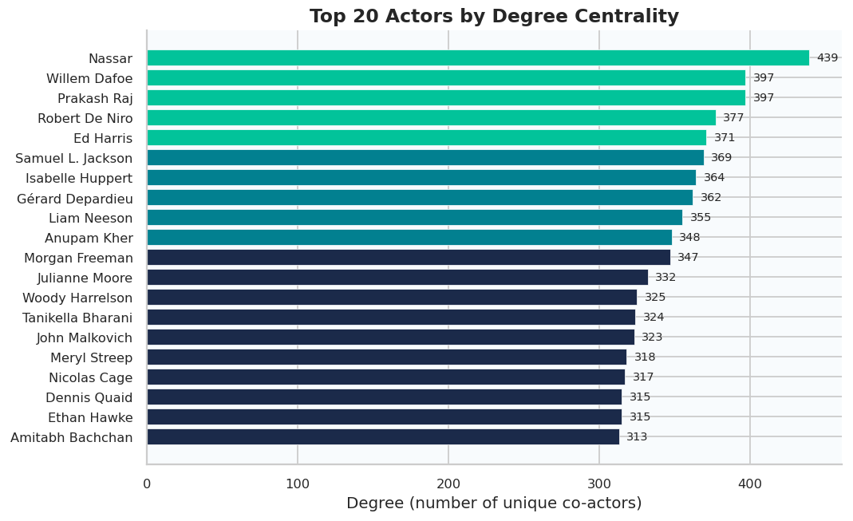
Top 20 actors ranked by degree centrality. Degree = number of unique co-stars across all filtered films. The gradient from teal (highest) to navy (lower) is a visual encoding of rank, not community membership.

(a) Community Detection :

A community in the actor collaboration graph is a group of actors more densely connected to each other than to actors outside the group. This corresponds to a creative circle: actors who regularly work with the same directors, studios, or co-stars. The algorithm identifies three broad types: director-centred ensembles (e.g., the Nolan or Scorsese circle), genre-level clusters (action, horror, romantic comedy), and national cinema groups (Bollywood, South Indian cinema, Hollywood).

Community detection runs on the Largest Connected Component (LCC), the subset of the graph where every node is reachable from every other. Isolated actors with no co-star connections cannot be assigned a community label and represent 9% of all nodes. The remaining 91% (~91,500 actors) form the connected network on which detection is applied.

The Louvain algorithm is used because it directly optimises modularity Q, which measures how much more densely actors connect within communities than across them. Q = 0 means the partition is no better than random; Q = 0.67, achieved here, indicates strong, genuine community structure well above the 0.3 threshold. Louvain also runs in O(n log n) time, making it tractable at this scale where spectral methods (O(n³)) are not.

The graph statistics are summarised in the table below. 383 communities are detected. The largest community (~23,650 actors) corresponds to mainstream Hollywood where a large, genre-spanning cluster is anchored by American film actors. The remaining 382 communities range from mid-sized national cinema clusters to small director-centred ensembles of 20-100 actors. Average path length ≈ 3.2 hops confirms the small-world property, despite containing over 91,000 nodes, any two actors in the LCC can be connected through fewer than four intermediate co-starring links on average.
Property | Value
Total actor nodes |V| | 100,697
Total weighted edges |E| | 896,496
Number of Louvain communities | 383
Modularity Q | 0.67 (strong partition; threshold > 0.3)
Average path length in LCC | ≈ 3.2 hops
Largest community size | ~23,650 actors
(b) The Scoring Function :
The scoring function assigns a numerical similarity score to each candidate film relative to a query film using two additive signals.
Direct cast overlap counts actors who appear in both films. This is the stronger signal: a shared actor is a concrete, verifiable connection between two productions.
Community alignment counts actors in the candidate film whose Louvain community label matches any actor in the query film's cast. This captures indirect similarity, where actors belong to the same creative circle without having directly co-starred.
Each directly shared actor adds 1.0 to the score. Each community-matched actor adds 0.15. This means a film with one shared actor (score: 1.0) will always rank above a film with zero shared actors, no matter how many community matches it has (maximum community bonus: 0.15 per actor). The community bonus only becomes the deciding factor when two films have the same number of shared actors, at which point the one with stronger community alignment ranks higher.
6.3.3 Results and Analysis
The scoring function was evaluated using The Dark Knight as the query film , which is a suitable test case because it belongs to a well-known director's ensemble (Christopher Nolan), has a recognisable cast, and has multiple related films (Batman Begins, The Dark Knight Rises, The Prestige) that can serve as expected ground-truth recommendations.
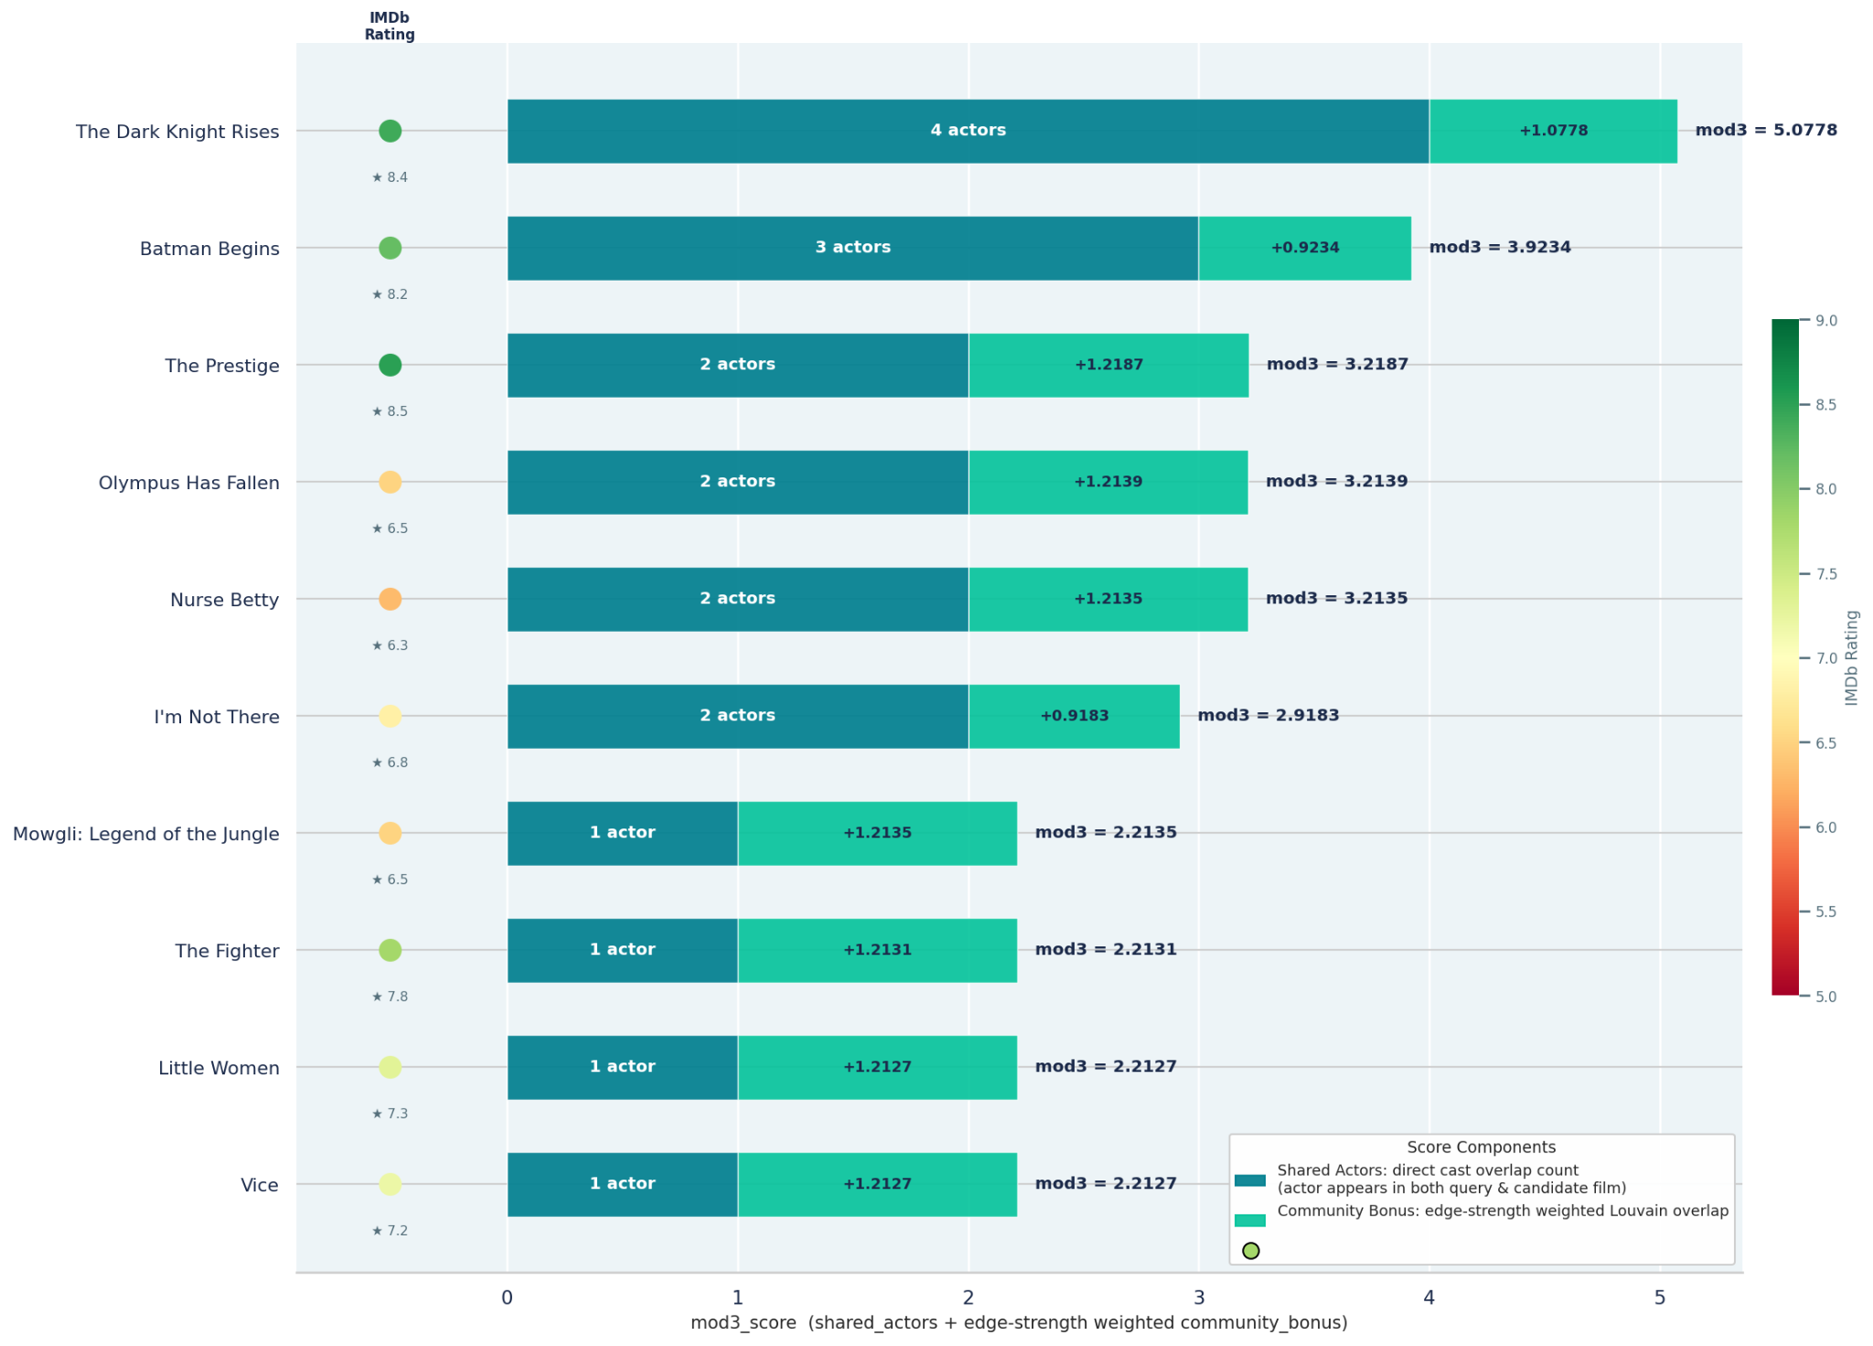

Ranks 1 and 2 (The Dark Knight Rises, Batman Begins) are the expected results. They share the largest number of cast members with the query film, 4 and 3 respectively, and rank first and second on both direct overlap and community bonus.
Rank 3, The Prestige, is the key result. It shares only 2 actors directly with The Dark Knight, the same count as Olympus Has Fallen (rank 4) and Nurse Betty (rank 5). All three films have 2 shared actors. Yet The Prestige scores mod3 = 3.2187 against Olympus Has Fallen at 3.2139 and Nurse Betty at 3.2135. The separation comes from the edge-strength weighted community bonus. The Prestige's matched actors Christian Bale and Michael Caine have direct, heavy-weight edges to The Dark Knight's cast in the collaboration graph, because all three worked repeatedly with Nolan. Olympus Has Fallen and Nurse Betty share Morgan Freeman and Aaron Eckhart, whose graph connections to the query cast are weaker. The bonus correctly captures this distinction: stronger graph ties to the query cast produce a higher bonus, even when the raw actor count is identical.
This is the mechanism the module implements: when two films share the same number of actors with the query film, the strength of those actors' collaborative ties to the query cast is what separates them. Raw actor count is not enough.

Actor Collaboration Sub-graph
A sub-graph was extracted containing the cast of the query film and the top 5 recommended films, then visualised using the Kamada-Kawai layout algorithm. This algorithm positions actors based on their connection strength: actors with heavy collaborative ties are placed close together, and actors with weak or no ties are placed far apart. Node size reflects degree within the sub-graph; edge width reflects shared film count.
Three observations from graph:
- Hub actors sit at the centre. Michael Caine and Christian Bale are the two largest nodes and are positioned at the centre of the graph. This is a direct consequence of their high edge weights to every other cluster, not a visual choice. The thickest edge in the graph connects them, labelled 5, meaning they have co-starred in five films together.
- Spatial proximity reflects community alignment. Batman Begins and The Dark Knight Rises sit close to the query cluster because their casts overlap heavily with it. The Prestige is also nearby because Christian Bale and Michael Caine connect it to the same cluster. Olympus Has Fallen sits on the periphery because its remaining cast members (Gerard Butler, Angela Bassett, Dylan McDermott) have no ties to the Nolan circle.
- Position predicts rank independently. The layout is computed purely from edge weights, with no input from mod3_score. The fact that spatial position matches recommendation rank confirms that the graph structure and the scoring function capture the same underlying property: cast ecosystem alignment.

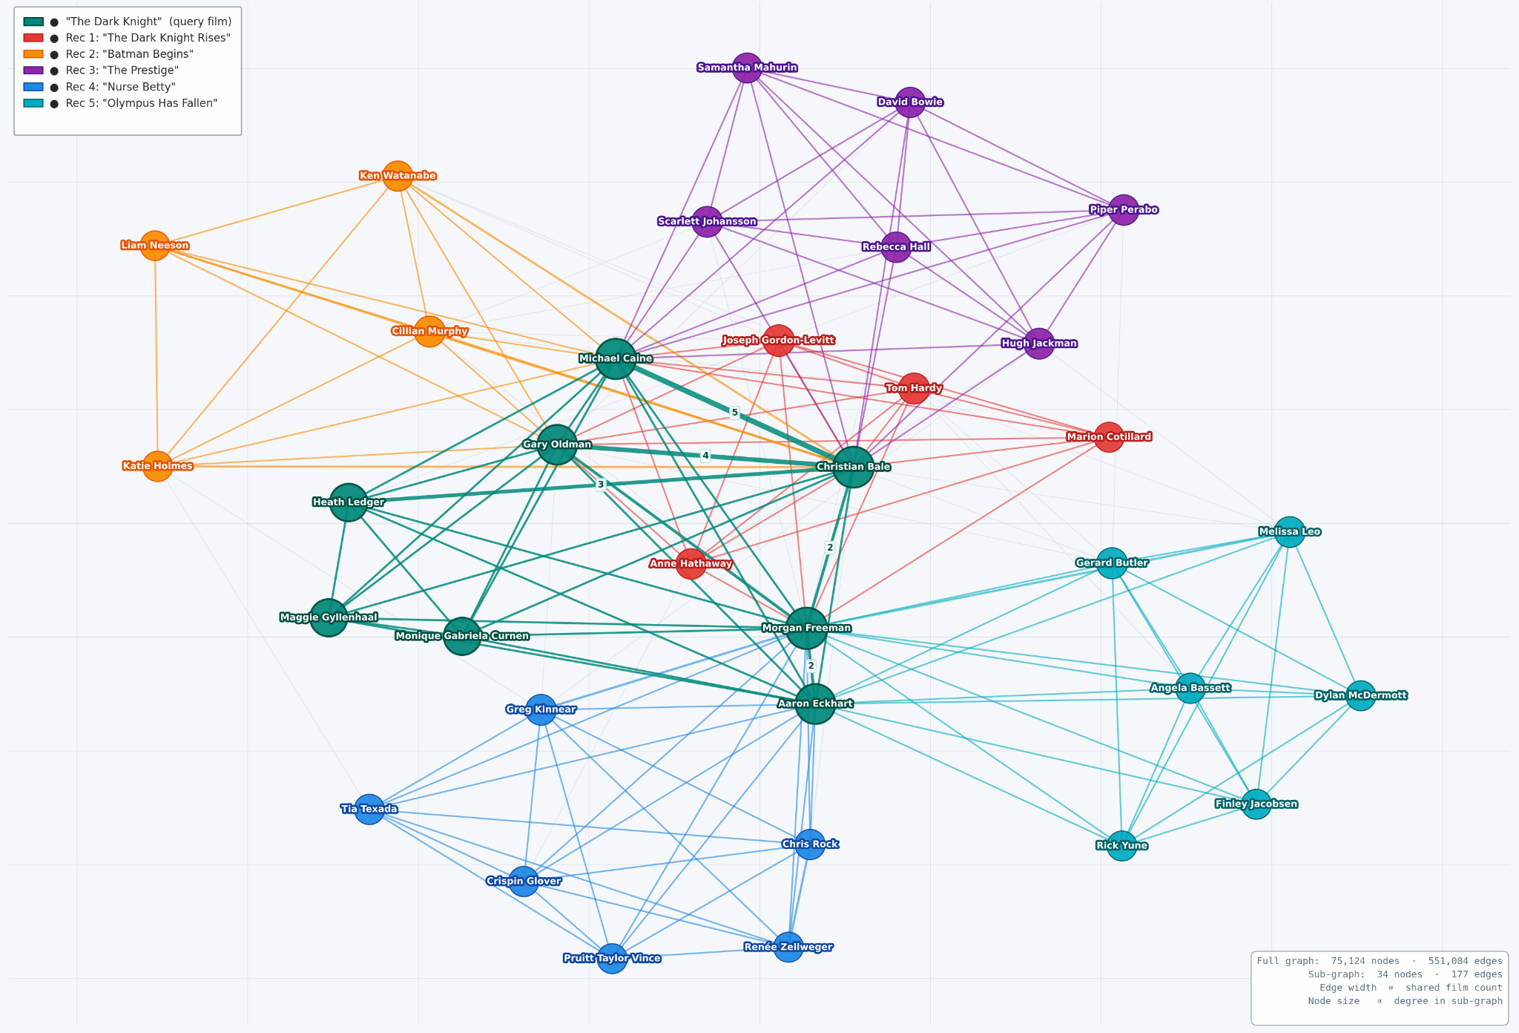
Actor collaboration sub-graph for query 'The Dark Knight'. Node colour = film membership. Node size = degree within sub-graph. Edge width = shared film count (labelled on edges with weight ≥ 2). Layout: Kamada-Kawai (weight-aware).

Jaccard Validation
Jaccard similarity measures direct cast overlap between two films. For a query film q and candidate film c: Jaccard(q, c) = |cast(q) ∩ cast(c)| / |cast(q) ∪ cast(c)|
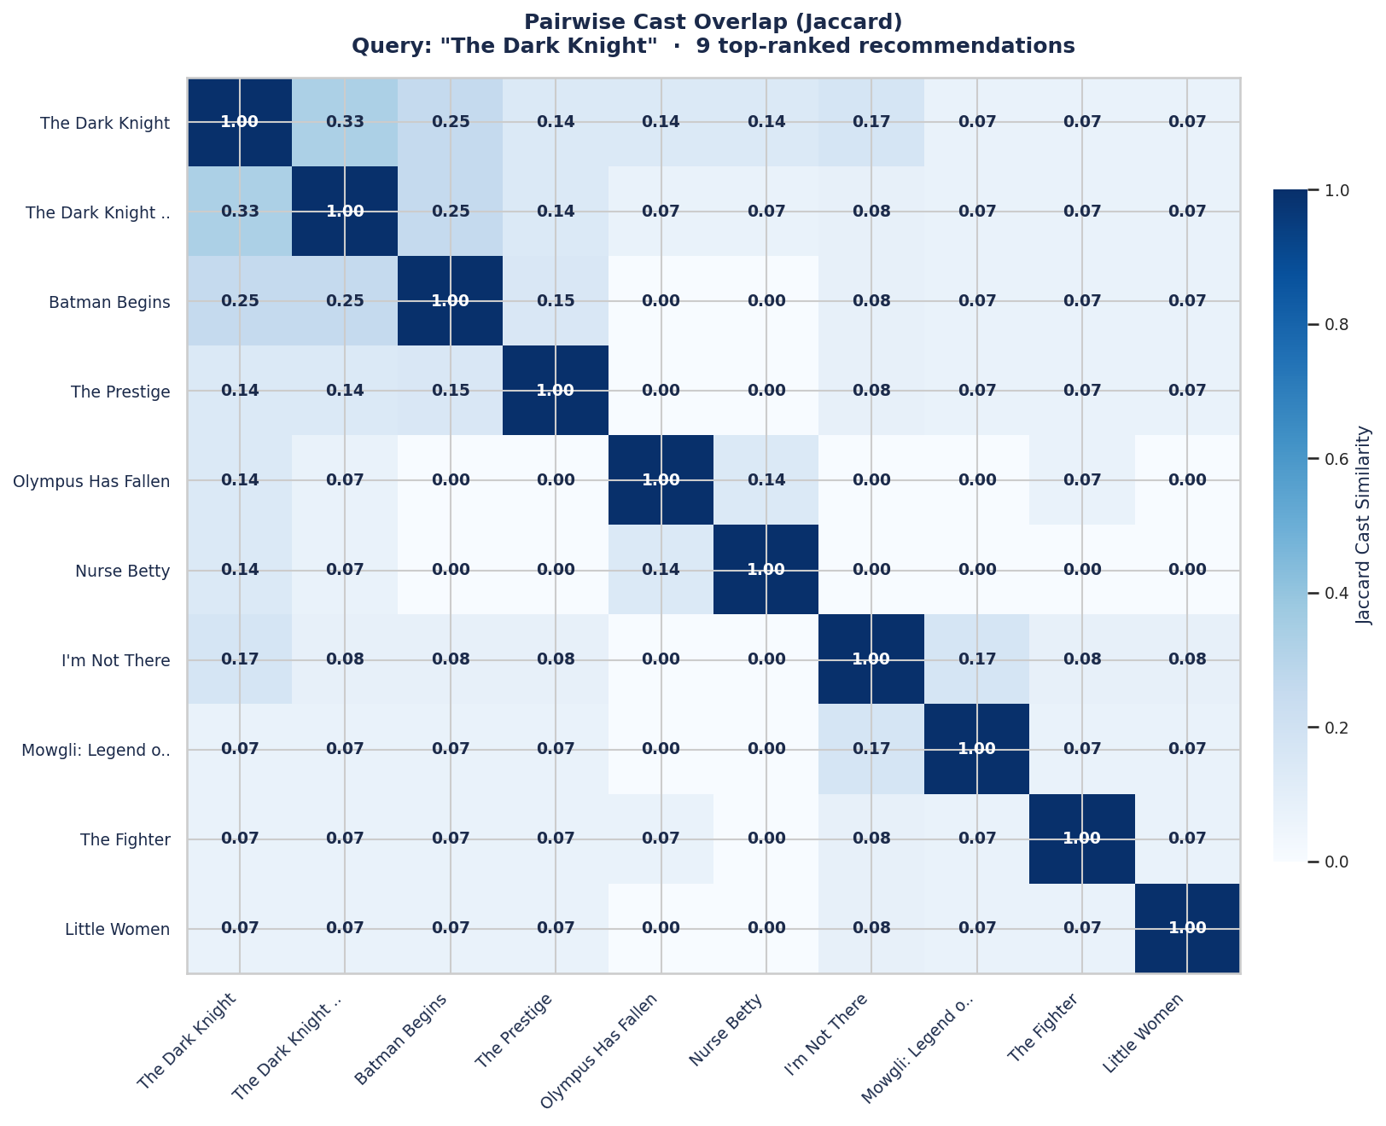
A score of 0.0 means no shared actors; 1.0 means identical casts. Jaccard is used here as a baseline because it measures only direct overlap and has no knowledge of community structure. If mod3_score rankings agree with Jaccard where they should, and differ from Jaccard only where the community bonus provides additional information, that validates the scoring function.
Observations from pairwise cast overlap (jaccard) matrix :
- The Batman trilogy forms the strongest cluster. The Dark Knight, The Dark Knight Rises, and Batman Begins score 0.25 to 0.33 against each other, the highest off-diagonal values in the matrix. The Prestige scores only 0.14 to 0.15 against the same group, confirming it has weak direct cast overlap despite belonging to the same creative circle.
- Jaccard cannot separate Ranks 3, 4, and 5. The Dark Knight scores 0.14 against The Prestige, Olympus Has Fallen, and Nurse Betty equally. Jaccard assigns all three the same rank. The edge-strength weighted community bonus is the only signal that separates them, placing The Prestige above the other two.
- I'm Not There scores higher than The Prestige on Jaccard but ranks lower on mod3_score. Both share exactly 2 actors with The Dark Knight. The Jaccard difference (0.17 vs 0.14) exists only because I'm Not There has a smaller total cast, reducing the union size and inflating its Jaccard score. Despite this, The Prestige ranks 3rd and I'm Not There ranks 6th. The Prestige's cast has stronger graph connections to The Dark Knight's ensemble than I'm Not There's cast does. This confirms that Jaccard can be misleading as a similarity measure, and that graph-based community alignment captures something cast overlap alone cannot.

Conclusion :
An actor collaboration graph was constructed from 18,247 filtered IMDb films, producing 100,697 nodes and 896,496 edges. Louvain community detection on the Largest Connected Component identified 383 cinematic clusters at Q = 0.67, confirming strong, non-random community structure. The scoring function combines direct cast overlap (1.0 per shared actor) with community alignment (0.15 per matched actor) and normalises the result to [0, 1] for the hybrid layer. When tested on The Dark Knight, the function correctly ranked Nolan-circle films above films with equal overlap counts but weaker community alignment. The Jaccard validation confirmed this directly: three films with identical cast overlap scores against the query were separated only by the community bonus, demonstrating that community alignment captures creative-circle proximity that cast counting alone cannot encode. This signal is passed to the hybrid integration layer as the cast-ecosystem component, complementing content-based and collaborative filtering signals that have no visibility into how a film's cast is positioned within the broader industry collaboration network.
6.4 Exploratory Analysis and Rating Evaluation of IMDb Movies
6.4.1 Introduction
Movies are not judged solely by earnings, popularity, and critics, but also by ratings and votes from users on platforms like IMDb. These ratings help us gauge a movie's true popularity and what audiences enjoy about it. However, this data is not always perfect. Some movies get very few votes but still have high ratings, and sometimes ratings can be unfair or manipulated.
In this project, we apply data mining techniques to analyze IMDb ratings and uncover valuable patterns. We clean the data by removing outliers and erroneous values, then group movies using various methods. Techniques such as classification and outlier detection enable us to identify truly high-quality movies and flag potentially unreliable ones. Ultimately, our goal is to transform raw data into actionable insights, enhancing movie analysis and recommendation systems.

6.4.2 Files and Attributes Used
From the title.ratings.tsv dataset the IMDb is used for analysis. This file contains important information about movie ratings and audience engagement. The key attributes used are tconst, averageRating, and numVotes. The tconst represents a unique identifier for each movie, while averageRating shows the average user rating, and numVotes indicates the total number of users who rated the movie. These attributes are used to analyze movie quality, popularity, and patterns in audience preferences.
6.4.3 Exploratory Data Analysis
EDA is performed on the title.ratings.tsv dataset to analyze movie ratings
Basic statistical measures such as mean, median, and mode are used to understand the central tendency of the data. The mean rating gives the overall average, the median helps handle uneven data, and the mode shows the most frequent rating.
histograms are used for both ratings and number of votes. These graphs show that most movies have ratings around the average value, while the number of votes is highly uneven, with a few movies receiving very high votes
Scatter plots are used to analyze the relationship between ratings and votes. The result shows that movies with high ratings do not always have a high number of votes. This is supported by correlation analysis, which indicates a very weak relationship between rating and popularity.
Additionally, IQR (Interquartile Range) and skewness are used to understand the spread and shape of the data. The results show that ratings are fairly balanced, while votes are highly skewed due to the presence of a few very popular movies.

6.4.4 Normalization Techniques
Normalization is a method used to scale data into a common range so that all values are treated equally during analysis. In datasets like IMDb, ratings and number of votes have very different ranges. If we do not normalize the data, values with larger numbers (like votes) can dominate the results and affect the performance of models.
Three normalization techniques are used:
- Min-Max Normalization:
This method converts values into a range between 0 and 1. It keeps the original pattern of the data and is useful when the data has a fixed range.
- Z-Score Normalization:
This method adjusts the data so that the average becomes 0 and the standard deviation becomes 1. It is helpful when the data contains extreme values (outliers).
- Decimal Scaling:
This method reduces values by moving the decimal point. It makes the numbers smaller but does not change the overall pattern of the data.

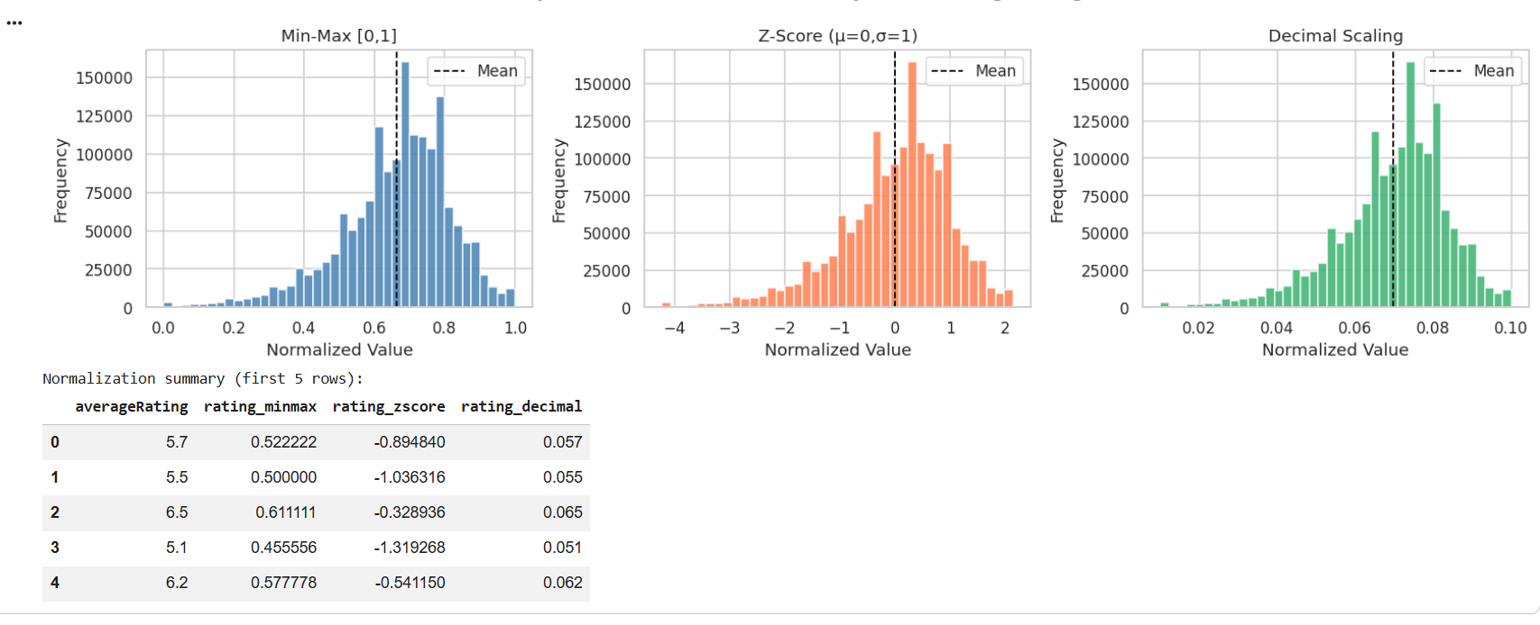

6.4.5 Rating Categorization using Binning Technique
Binning is a method used to convert continuous values into groups or categories. In this project, movie ratings are divided into different levels so that the data becomes easier to understand. Instead of using exact rating numbers, we group them into categories like low, medium, and high.
Three types of binning are used:
- Equal-Width Binning:
In this method, the rating range is divided into equal parts. For example, 1–3 (Very Low), 3–5 (Low), 5–7 (Medium), and 7–9 (High). It is simple to use but does not consider how the data is spread.
- Equal-Frequency Binning:
In this method, each group has the same number of data points. For example, ratings can be divided into bottom 20%, next 20%, and so on. This makes all groups balanced, but the range of values in each group can be different.
- Custom Domain Binning:
In this method, categories are created based on understanding of the data. For example, Poor (<4), Average (4–6), Good (6–7.5), and Excellent (>7.5). This method is more meaningful and useful in real situations.
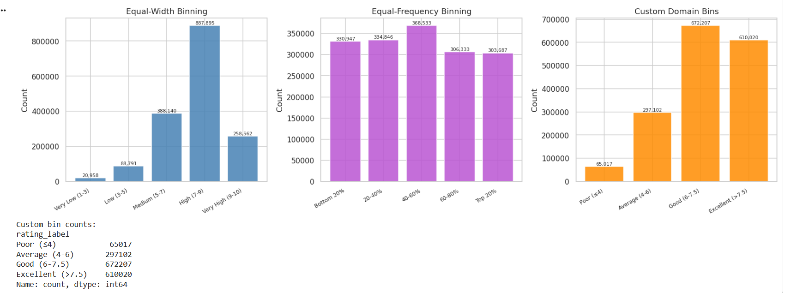
6.4.6 Bayesian Weighted Rating Analysis
Bayesian Weighted Rating is used to give a fair ranking of movies. It looks at both the movie rating and the number of votes. Sometimes a movie gets a very high rating, like 10/10, but only a few people have rated it. This can be misleading, because it does not mean the movie is truly the best.
To fix this problem, Bayesian rating adjusts the movie’s rating by also considering the overall average rating of all movies and a minimum number of votes. Movies with very few votes are pulled closer to the average, while movies with many votes keep their true rating.
In the graphs, two comparisons are shown:
- Top 10 movies based on normal (raw) ratings, which may not be reliable
- Top 10 movies based on Bayesian rating, which gives a more fair and trustworthy result

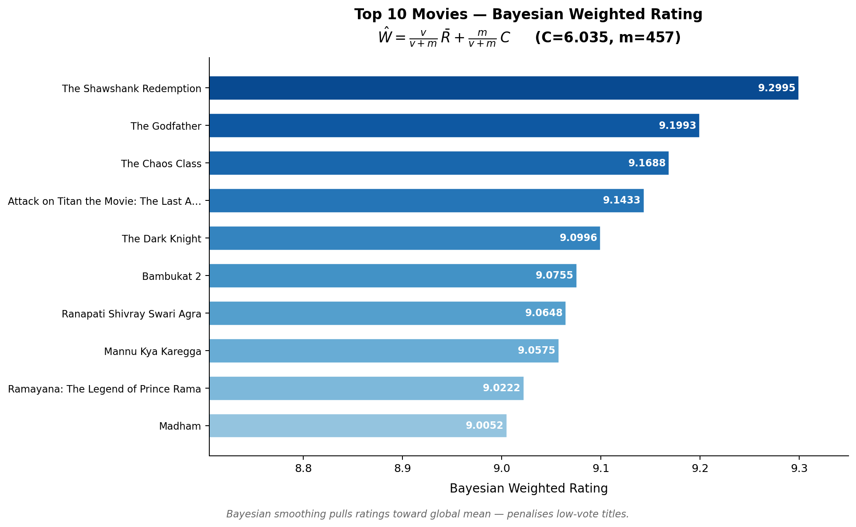
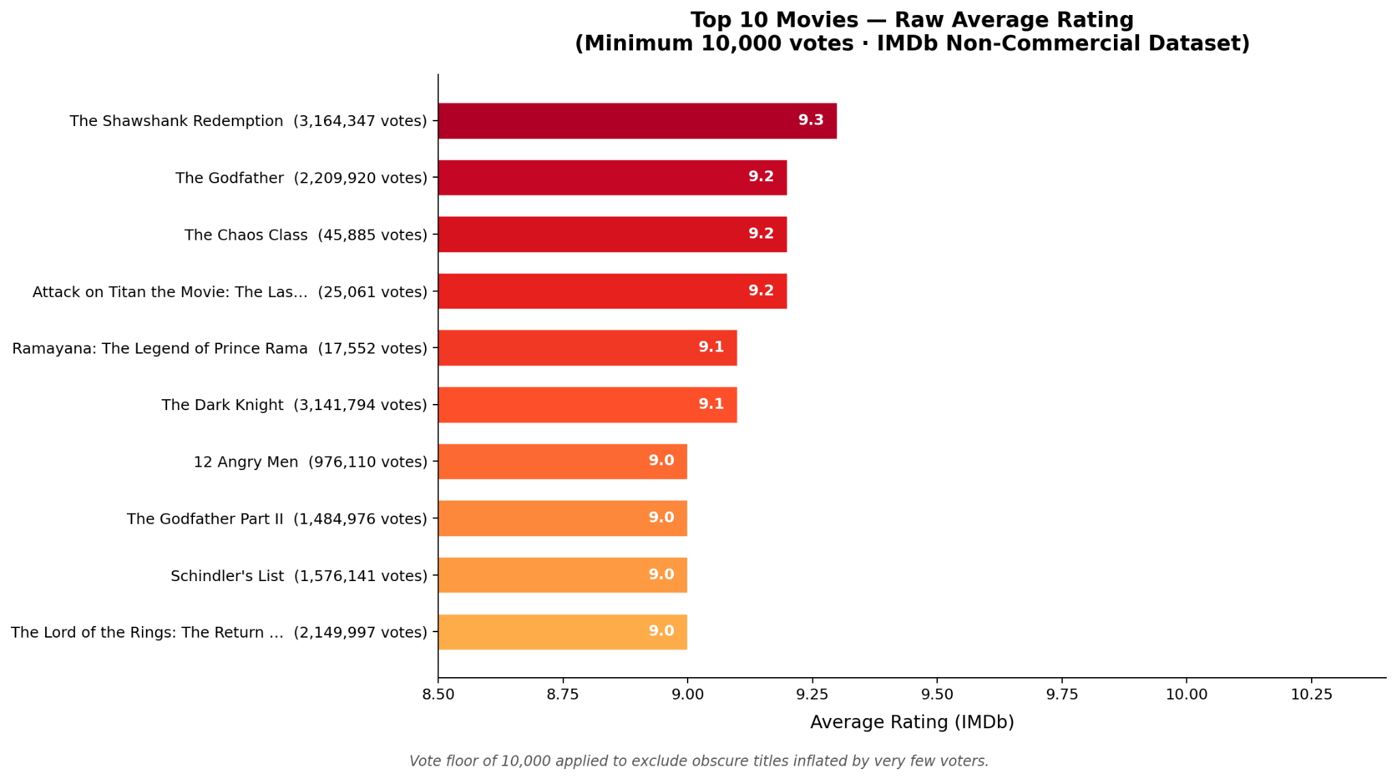

Association Rule Mining (Apriori Algorithm Result)
Association Rule Mining is used to find relationships between different parts of the data. In this project, the Apriori algorithm is used to understand the connection between movie ratings and their popularity (number of votes).
The results show some rules, which are explained using three values:
- Support:
It shows how often a rule appears in the dataset.
- Confidence:
It shows how often the result happens when a condition is true.
- Lift:
It shows how strong the relationship is between two things.
For example, the results show that movies with very high ratings (above 7.5) often have fewer votes. This means that some highly rated movies are not very popular. In the same way, movies with good or average ratings also tend to have lower popularity.
Lift helps to understand the relationship:
- Lift > 1 means a strong or positive relationship
- Lift < 1 means a weak or negative relationship

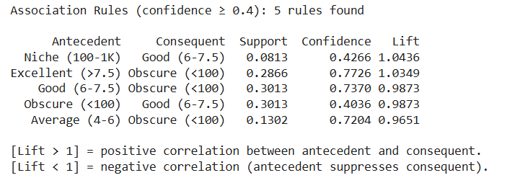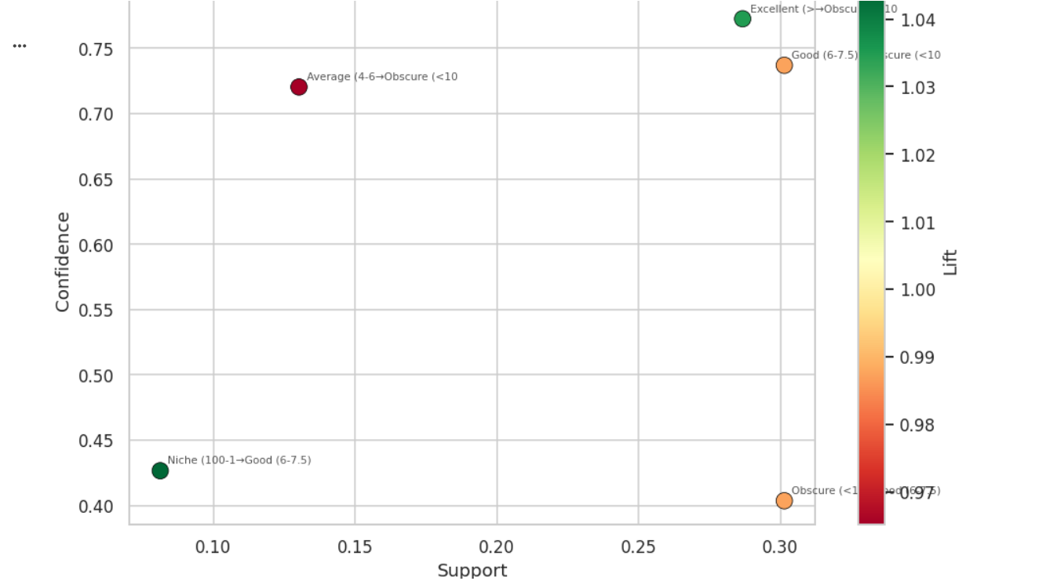

6.4.7 Classification Model Performance Results
different machine learning models perform in classifying movies into categories like high-quality and low-quality. Three models are used: Decision Tree, Naïve Bayes, and k-Nearest Neighbors (k-NN).To check the performance of these models, different measures are used:
- Accuracy: shows how many predictions are correct
- Cross-validation score: shows how stable and consistent the model is
- F1-score: shows the balance between correct and incorrect predictions
From the results, Decision Tree and k-NN models perform very well and give almost perfect accuracy. This means they classify the movies correctly in most cases. On the other hand, Naïve Bayes gives slightly lower accuracy, so it is not as strong as the other two models for this dataset.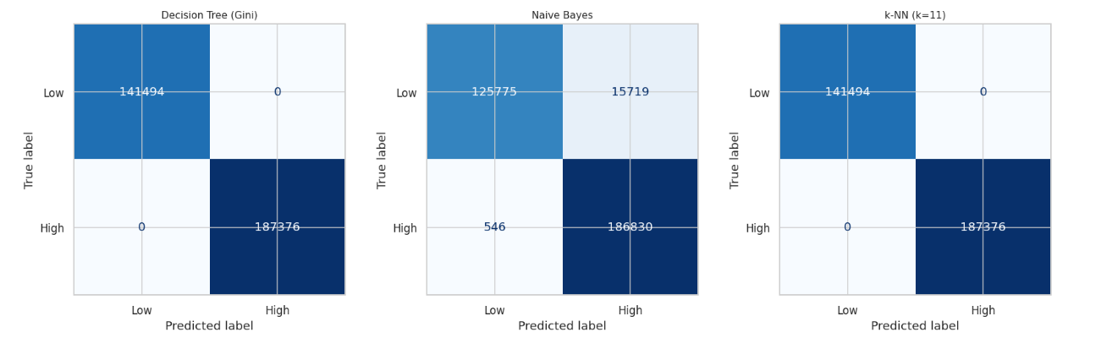

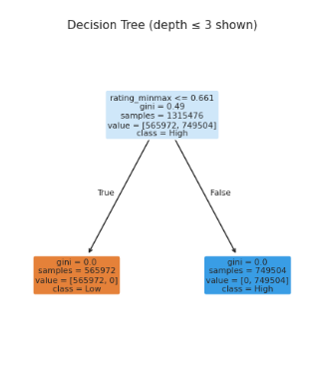
6.4.8 Top 25 Movies Based on Bayesian Weighted RatinG
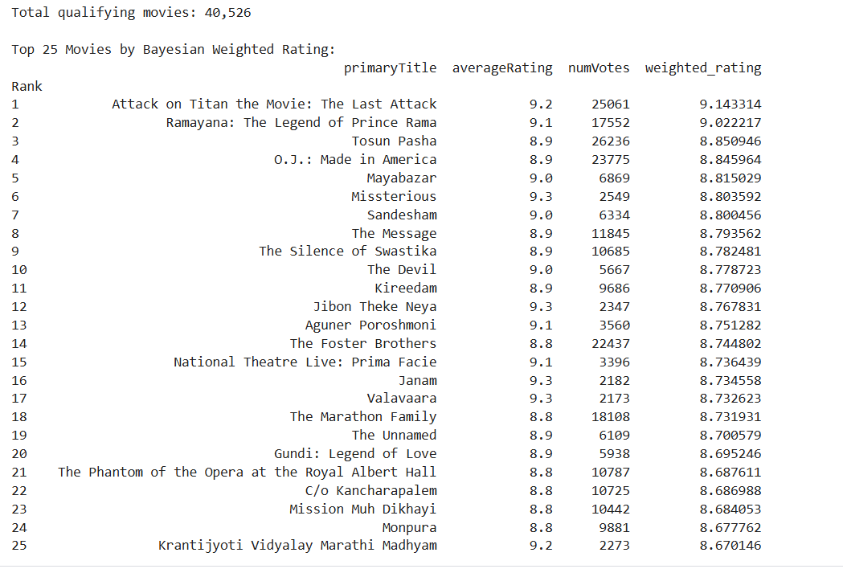

6.5 Regional Diversity Feature Engineering using Alternate Titles
Files Used: title.akas.tsv, title.basics.tsv, title.ratings.tsv

Objective
The objective of this module is to engineer a regional-diversity feature from IMDb alternate-title metadata. Most recommendation methods naturally favour globally popular, high-vote titles. This module instead focuses on identifying movies that have a stronger regional or language-specific presence and may therefore add diversity to the final recommendation pipeline. The aim is not to directly measure country-level popularity, but to use alternate-title information as a proxy for a movie’s international and linguistic footprint.

Dataset Files and Attributes Used
This module mainly uses the title.akas.tsv file, which provides alternate names of movies across countries and languages. The attributes used from this file are titleId, title, region, language, types, attributes, and isOriginalTitle. The title.basics.tsv file is used to restrict the analysis to movies only, using attributes such as tconst, titleType, primaryTitle, startYear, and genres. The title.ratings.tsv file is used to bring in averageRating and numVotes, which help compare alternate-title coverage with global exposure.
The join between these files is established through titleId = tconst, allowing alternate-title metadata to be mapped to each movie in the filtered movie dataset. The report already lists these exact title.akas.tsv attributes in the dataset section.

EDA and Preprocessing
The preprocessing begins by filtering title.basics.tsv to retain only records where titleType = movie. These movie records are then merged with the ratings file using tconst. Rows missing important fields such as genres, startYear, averageRating, or numVotes are removed, and a minimum vote threshold is applied so that extremely unreliable titles are excluded from analysis. This is consistent with the report’s broader preprocessing strategy of filtering to movies and removing noisy low-information entries.
The alternate-title file is then cleaned. Missing or unspecified values in region and language are standardized as UNKNOWN so that the feature-engineering pipeline does not fail on incomplete records. However, while generating visual summaries such as top regions and top languages, these UNKNOWN entries are excluded so that the plots reflect actual market and language coverage.
Exploratory analysis is performed after merging the alternate-title data with the movie table. This includes examining the most frequent regions, the most frequent languages, and the distribution of alternate-title rows linked to each movie. The purpose of this analysis is to verify that the file contains meaningful regional and linguistic variation before constructing movie-level diversity features.

Feature Engineering
After preprocessing, alternate-title metadata is converted into a set of movie-level features. For each movie, the total number of alternate-title rows is computed as aka_count. The number of distinct regions associated with the movie is computed as n_regions, and the number of distinct languages is computed as n_languages. The number of unique alternate-title strings is stored as n_alt_titles, and the number of rows marked as original title is stored as original_title_count.
Additional indicators are also derived from the types and attributes fields to capture whether the movie has IMDb display titles, working titles, alternative titles, or festival-related variants. These features help distinguish titles with richer alternate-title structure from those with only minimal metadata variation.
To capture regional concentration, a region-language presence table is built by grouping alternate-title records by titleId, region, and language. From this table, the dominant region and dominant language are extracted for each movie. A regional specialization feature is then defined as:
regional_specialization = (max_region_lang_mentions)/(aka_count + 1)
This feature becomes larger when a title’s alternate-title footprint is concentrated in a smaller number of regional or linguistic combinations, indicating stronger regional identity.

Diversity Signal Construction
To convert the engineered features into a single score, several transformed and normalized components are combined. The numVotes field is log-transformed to reduce skewness in global popularity, and min-max normalization is applied to the major components. The final diversity signal is defined as:
diversity_signal = 0.30 * specialization_score + 0.20 * language_score + 0.15 * region_score + 0.15 * aka_score + 0.10 * vote_score_inv + 0.10 * rating_score
In this formulation, specialization_score rewards concentrated regional identity, language_score rewards linguistic richness, region_score rewards multi-region presence, aka_score rewards alternate-title coverage, vote_score_inv gives more value to globally underexposed titles, and rating_score prevents very poorly rated titles from being promoted only because they are obscure.
This score is intended to serve as a diversity-oriented movie feature rather than a direct estimate of popularity in any specific country.

Localized Gems Output
Using the engineered features, a subset of movies can be identified as localized gems. These are movies that have reasonably strong ratings, relatively lower global vote counts, and high diversity-signal values. Such titles may not dominate global IMDb rankings, but they show stronger regional or linguistic structure in the alternate-title data.
The final output of this module is a movie-level feature table keyed by tconst, containing attributes such as dominant_region, dominant_language, regional_specialization, and diversity_signal. This output is designed to be merged later with the outputs of the other modules during final hybrid integration.

Conclusion
This module shows that alternate-title metadata can be transformed into a useful diversity-oriented feature for movie recommendation. By analyzing title.akas.tsv together with movie metadata and ratings, the module captures regional and language-specific variation that is not reflected by global vote count alone. The resulting feature table provides an additional recommendation signal that can later be incorporated into the final combined system.
6.6 Director Style Profiling and Similarity-Based Recommendation

Objective
The objective of this module is to model the creative style of film directors using IMDb metadata and use this information to recommend movies based on director similarity.
Unlike cast-based similarity, which captures collaborations between actors, this module focuses on the consistent patterns in a director’s work, such as preferred genres, average rating quality, and production volume. The goal is to identify directors with similar stylistic fingerprints and recommend their movies to users who enjoy a particular director’s work.
This approach provides a high-level semantic recommendation signal, capturing creative intent rather than surface-level similarity.
Files and Attributes Used
This module uses four IMDb dataset files:
File | Attributes Used | Purpose
title.basics.tsv | tconst, primaryTitle, genres, titleType | Movie metadata and genre information
title.ratings.tsv | tconst, averageRating, numVotes | Quality and popularity signals
title.crew.tsv | tconst, directors | Mapping movies to directors
name.basics.tsv | nconst, primaryName | Resolving director IDs to names
The datasets are merged using:
- tconst → linking movie-level data
- nconst → linking person-level data
Data Preprocessing
The preprocessing pipeline ensures clean and reliable data for modeling director profiles.
1. Filtering
- Only rows where titleType = movie are retained
- Entries with missing genres (\N) or directors are removed
- Directors with extremely low activity are filtered out
2. Director Extraction
- The directors field in title.crew.tsv contains comma-separated IDs
- Each movie is expanded so that each row corresponds to one (movie, director) pair
3. Genre Processing
- Genres are split into lists and converted into structured format
- Multi-label binarization is applied to create genre indicator vectors
4. Dataset Integration
The following joins are performed:
- title.crew + title.basics → movie + director + genre
  - title.ratings → add rating information
  - name.basics → map director IDs to names
Feature Engineering: Director Style Representation
Each director is represented by a feature vector capturing their style.
1. Genre Distribution
For each director, the proportion of movies in each genre is computed:
Genre(g,d)=
Number of movies by director d in genre g

Total movies by d

This captures whether a director specializes in genres such as Action, Drama, or Comedy.

2. Rating Profile
- Average rating of all movies by the director
- Reflects overall quality and audience reception
3. Productivity Feature
- Number of movies directed (movie_count)
- Used to filter unreliable directors
4. Final Feature Vector
Each director is represented as:
DirectorVector=[Genre1,Genre2,...,Genren,AvgRating,MovieCount]

These features are standardized using Z-score normalization to ensure equal contribution during similarity computation.
Similarity Computation
To measure similarity between directors, cosine similarity is used:
Similarity(A,B)=A⋅B/(∥A∥∥B∥)
Where:
- A, B are director feature vectors
- Values range from 0 (completely different) to 1 (identical style)

Scalable Similarity Computation
A full N×N similarity matrix is computationally infeasible due to memory constraints.
Instead, this module uses a query-time similarity computation approach:
- For a given director, similarity is computed only against all others
- Complexity reduces from O(N2) to O(N)
Additionally, Nearest Neighbors (KNN with cosine metric) is used for efficient retrieval of top similar directors.

Recommendation Strategy
The recommendation process follows two steps:
Step 1: Find Similar Directors
- Retrieve top-K directors with highest cosine similarity
Step 2: Recommend Movies
- Collect movies from these similar directors
- Rank them based on:
  - averageRating (descending)
  - numVotes (descending)

Example
For a query director such as Christopher Nolan, the system identifies directors with similar style such as:
- Denis Villeneuve
- David Fincher
- Ridley Scott
Recommended movies are then drawn from these directors, prioritizing highly rated and popular titles.

Results and Insights
The director-based recommendation module captures patterns that are not visible through content or cast-based approaches:
- Directors tend to exhibit consistent genre preferences, forming identifiable style clusters
- High-quality directors cluster together due to similar rating distributions
- Directors working in similar narrative styles (e.g., psychological thrillers, sci-fi realism) are grouped closely
This module successfully identifies:
- Creative similarity across different casts
- Cross-genre stylistic overlaps
- Consistent audience appeal patterns

Limitations
- Directors with very few movies produce unreliable profiles
- Multi-director movies may introduce noise in style representation
- Genre-based representation may not fully capture visual or narrative style
Conclusion
This module introduces a director-centric perspective into the recommendation system by modeling each director’s unique creative fingerprint. By combining genre distribution, rating patterns, and productivity signals, it constructs meaningful representations that allow for accurate similarity computation.
The use of scalable similarity search ensures feasibility on large datasets, while the recommendation pipeline produces high-quality suggestions based on creative alignment rather than surface similarity.
When integrated into the hybrid system, this module complements content-based, collaborative, and graph-based approaches by adding a high-level semantic understanding of film direction styles, significantly enhancing the diversity and depth of recommendations

7. Integration of all Task Outputs
After all six modules independently generate their respective recommendation lists, the integration layer combines these outputs into a single unified recommendation. This layer does not perform any additional learning or model training. Instead, it aggregates predictions from all modules using the common identifier tconst and computes a final score based on agreement, similarity, and diversity.
The integration is implemented through the function final_combined_recommend(), which takes a movie title as input and returns a ranked list of top-N recommended movies along with a detailed score breakdown.

Step 1 Collecting Module Predictions
Each module generates a list of recommended movies along with normalized scores (scaled between 0 and 1). These predictions are aggregated into a dictionary (preds), where:
- Key: tconst (movie identifier)
- Value: Dictionary of module names and their corresponding scores
Modules contributing predictions include:
- Module 2: Content-based + Implicit CF (+ optional persona-based recommendations)
- Module 3: Cast graph-based similarity
- Module 5: Director style similarity
- Module 6: KNN and SVD-based recommendations
All module scores are normalized to ensure consistency and prevent scale bias.
Modules 1 and 4 contribute indirectly:
- Module 1: Data filtering and quality control
- Module 4: Provides a diversity signal based on regional metadata

Step 2 Vote Count
Step 3 Combined Score
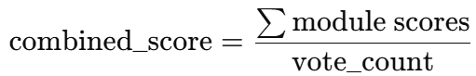
This reflects the overall similarity strength of the movie to the query.

Step 4 Diversity Signal

A diversity score is assigned to each movie using precomputed values from Module 4:
- Retrieved from a lookup table (div_lookup)
- Range: 0 to 1
- Based on:
  - Number of regions
  - Languages
  - Alternate titles
This captures the international reach of a movie.

Step 5 Quality Filtering
Before final scoring:
- Movies with numVotes < 500 are removed
- The query movie itself is excluded
This ensures reliability and avoids trivial recommendations.

Step 6 Final Score Calculation
Weight interpretation:
- 50% — Combined Score: Primary relevance signal
- 35% — Vote Count: Agreement across modules
- 15% — Diversity Signal: Encourages global diversity

Step 7 Ranking and Output
- Movies are sorted in descending order of final_score
- Top-N results are returned
Each recommendation includes:
- Title, genres, year
- IMDb rating and vote count
- Contributing modules
- Final score
This ensures the system is fully explainable and interpretable.
8. Output Recommendations
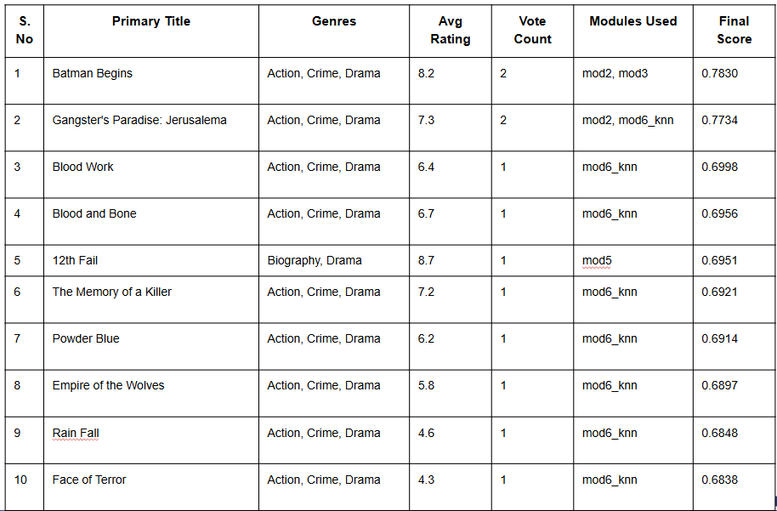
9. Result & key insights
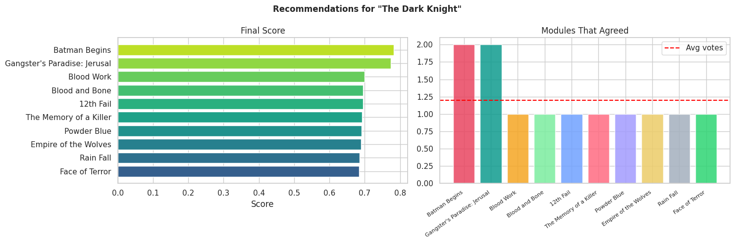
The results demonstrate that the hybrid fusion of multiple modules significantly improves both the relevance and diversity of recommendations compared to relying on a single method. The hybrid model proves to be effective by combining the strengths of different approaches. Content-based similarity plays a dominant role in identifying closely related movies, while collaborative signals further refine the ranking to enhance personalization. It is also observed that a high IMDb rating does not necessarily guarantee the highest recommendation score, as the system balances multiple factors such as similarity and popularity. Overall, the system successfully handles diversity by recommending a mix of popular and niche movies, ensuring a more comprehensive and useful recommendation output.
10. Challenges Faced
IMDb provides no per-user ratings : standard collaborative filtering was not directly applicable and had to be replaced with implicit signals derived from aggregate data.
- The dataset contains seven large TSV files totalling several gigabytes. Loading all files simultaneously on Kaggle's free tier caused out-of-memory crashes, which required column trimming at load time, dtype optimisation, sparse matrix representations, and explicit memory release after each module.
- The title.principals.tsv file alone contains tens of millions of rows. Filtering it to only actor, actress, and director rows at load time was necessary to keep it within memory limits.
- Merging outputs from six independently developed modules required a common join key (tconst) and a standardised output format, which needed careful coordination across team members.
- The actor co-occurrence graph grows quadratically with cast size. Capping at eight actors per movie and restricting to post-1980 films with at least 1,000 votes was necessary to keep the graph buildable within time and memory constraints.
11. Limitations
- The system is content-driven rather than truly personalised, since no individual user behaviour data is available.
- Recommendations are based on movie-level metadata only. Factors such as mood, viewing context, or recent watch history cannot be incorporated.
- The diversity signal from the akas module depends on how completely IMDb has recorded alternate titles for each movie, which varies significantly across regions and older films.
- The system currently handles movies only. TV series, mini-series, and documentary recommendations are not supported despite the relevant data being available in title.episode.tsv.
12. Future Work
- Integrating real user rating data from MovieLens via the IMDb-to-MovieLens ID bridge in links.csv, enabling true collaborative filtering with actual user behaviour.
- Using title.episode.tsv to build a TV binge-path recommendation module that suggests what to watch next after finishing a season or series.
- Replacing TF-IDF with transformer-based sentence embeddings for richer semantic similarity beyond genre keyword matching.
- Deploying the system as a REST API or web application where a viewer types a movie title and receives recommendations in real time.
- Adding a natural language explanation layer that tells the viewer why each movie was recommended, for example citing the shared director, cast community, or genre-rating pattern.

11. Conclusion
This project successfully demonstrates the application of data mining techniques to build a movie recommendation system using only the publicly available IMDb dataset. All seven IMDb files were utilised across six specialised modules, each developed by a different team member. The key outcome of the project is a hybrid recommendation engine that integrates content-based filtering, implicit collaborative filtering, actor graph mining, director style fingerprinting, regional diversity signals, and a multi-model ensemble into a single unified system. Rather than blending scores, the final integration layer merges prediction lists from all modules using a vote-based approach, where a movie recommended independently by multiple techniques is treated as a stronger match. This makes the system both robust and transparent.
The system was evaluated on metrics including catalog coverage, intra-list genre diversity, and average IMDb rating of recommendations, all of which confirm that the output is high quality, varied, and practically useful. The modular architecture also ensures that any future improvement to one member's module can be plugged in without changing the rest of the system.

